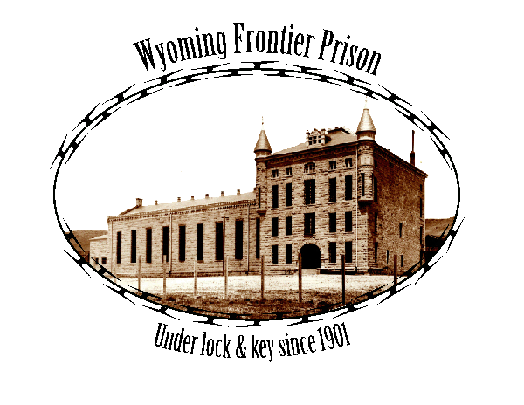

THE MARK J. SETRIGHT SCHOLARSHIP FUND
Wyoming Frontier Prison
500 West Walnut Street
Rawlins, WY 82301
307-324-4422

Application Due Date: April 13, 2018

The Mark J. Setright Scholarship Fund will provide one $500.00 scholarship, to be used for educational expenses, to Wyoming Frontier Prison Tour Guides who will be attending or who are attending any accredited post-secondary institute at any level; including a university, junior college or trade school. The funds will be sent directly to the financial office of the school the student will attend.

Applicants will be selected by the Mark J. Setright Scholarship Committee, which is made up of members of the Old Pen Joint Powers Board, the Friends of the Old Pen, and the Setright Family.

Criteria for Selection:

- Applicant must have “served time” as a Wyoming Frontier Prison tour guide. As a tour guide, applicant must have exhibited strong work ethics, volunteer time, and a passion for the Old Pen and the story it has to tell.
- Applicant must show evidence of enrollment in an accredited post-secondary institute.
- Applicant must graduate from high school with a minimum of a 3.0 G.P.A and be in good standing.
- Applicant must provide three letters of reference.

THE MARK J. SETRIGHT SCHOLARSHIP FUND

PERSONAL STATEMENT

Applicant’s Name: ________________________________________________________

Address: _________________________________Telephone Number: ______________

Number of years as a Tour Guide: _______Dates employed as a Tour Guide: _________

Name of School you plan to or are attending: ___________________________________

In what field do you plan to enroll? ___________________________________________

Please answer the following questions. Use additional pages if necessary:

Scholastic Awards and Achievements:

Extra Curricular School Activities:

Non-School Activities and Part-time Employment during High School:

Educational Plans:

Career Plans:

Applicant must write a grammatically correct, minimum 300-word essay, typed, and double-spaced discussing what they learned while working as a Wyoming Frontier Prison Tour Guide.

Thank you,
Mark J. Setright Scholarship Committee

